Mathematics Specialist Unit 4

Test 4: Calculus **Solutions**

**Student Name:** _____________________________

**Time allowed for this task:** 55 minutes, in class, under test conditions

Section One – calculator-free section 35 minutes (35 marks)

Section Two – calculator-assumed section 20 minutes (20 marks)

**Materials required:** (to be provided by the student)

Calculator with CAS capability.

Formula Sheet

Notes on one unfolded sheet of A4 paper.

Standard items: Pens (blue/black preferred), pencils (including coloured), sharpener, correction fluid/tape, eraser, ruler, highlights.

Special items: Drawing instruments, templates, and up to three calculators approved for use in WACE examinations.

**Marks available:** 55 marks

**Task weighting: 7%**

**Section One – calculator-free section (35 marks)**

**Question 1. (10 marks)**

1. Find $\int{\tan^{2}}4xdx$ using a suitable trigonometric formula. (2 marks)

✓

✓

1. Find $\int{(4x+3){(2x+1)}^{5}}dx$ using a suitable substitution. (4 marks)

✓

✓

= ✓

=  ✓

1. Find $\int{\frac{x+4}{(x+2)(x+1)}}$ $dx$ using partial fractions. (4 marks)

Put $\frac{x+4}{(x+2)(x+1)}=\frac{A}{x+2}+\frac{B}{x+1}=\frac{A\left(x+1\right)+B(x+2)}{(x+2)(x+1)}⇒$ $A+B=1$ and

✓✓

✓

✓

**Question 2. (9 marks)**

1. Determine the volume of the solid formed when the area in the first quadrant and enclosed by $y=x^{2}$, the line $y=3$ and the $y axis$ is rotated through one revolution about the $y axis.$ (4 marks)

$V_{y}=π\int_{m}^{n}{x^{2}}$ dy ✓

dy ✓

✓

✓

1. The area in the first quadrant enclosed by the curve $y=$ $\frac{1}{x^{2}}$, the lines $x=1,$ $x=k, k>1$ and the *x-*axis is rotated $360°$ about the *x*-axis. If the volume of the solid generated is $\frac{21π}{64}{units}^{3}$ determine the value of the constant k. (5 marks)

$V_{x}=π\int_{a}^{b}{y^{2} }$*dx*

✓

✓

✓

✓

✓

**Question 3. (8 marks)**

1. Determine $\int_{\frac{π}{6}}^{\frac{π}{2}}{ }\cos^{3}xdx$ using the substitution $u=sinx$. (4 marks)

✓

✓

✓

✓

1. Show that $\int_{\frac{π}{4}}^{\frac{π}{2}}{ }$ $\frac{sinx-cosx}{sinx+cosx}$ $dx=\frac{1}{2}ln2$ (4 marks)

✓

)) ✓

✓

✓

**Question 4. (8 marks)**

1. Use the substitution $tanθ=x+2$ to determine $\int{\frac{4}{x^{2}+4x+5}}$ $dx$ (4 marks)

✓

✓

✓

✓

1. Find $\int{\left(sin2x+cos2x\right)cos2xdx}$ (4 marks)

✓

✓✓

✓

**End of Section One**

**Section Two – calculator-assumed section (20 marks)**

**Question 5. (4 marks)**

The area enclosed by the $x$ axis, the lines $x=1$ and $x=4$ and the curve $y=1+\sqrt{x}$ is rotated $360°$ about the $x$ axis. Calculate the volume of the solid generated to an accuracy of two decimal places. (4 marks)

✓

✓

✓✓

**Question 6. (6 marks)**

1. Find $\int{\frac{5x^{2}-10x-3}{(x+1){(x-1)}^{2}}}$ $dx$ using partial fractions. (3 marks)

✓

**+ 2ln+**  ✓✓

1. Hence express $\int_{2}^{5}{\frac{5x^{2}-10x-3}{(x+1){(x-1)}^{2}}}$ $dx$ as a single logarithm. (3 marks)

✓

✓

) ✓

**Question 7. (10 marks)**

|  |  |
| --- | --- |
| *x* | *f(x)* |
| 3.0 | 2.87 |
| 3.2 | 2.90 |
| 3.4 | 2.94 |
| 3.6 | 2.97 |
| 3.8 | 3.00 |
| 4.0 | 3.04 |
| 4.2 | 3.08 |
| 4.4 | 3.12 |
| 4.6 | 3.16 |
| 4.8 | 3.20 |
| 5.0 | 3.25 |
| 5.2 | 3.30 |
| 5.4 | 3.36 |
| 5.6 | 3.42 |
| 5.8 | 3.49 |
| 6.0 | 3.56 |
| 6.2 | 3.64 |
| 6.4 | 3.73 |
| 6.6 | 3.82 |
| 6.8 | 3.92 |
| 7.0 | 4.03 |

Consider the region enclosed by the curve $y=f\left(x\right), x=3, x=7$

and the $x$ axis. y

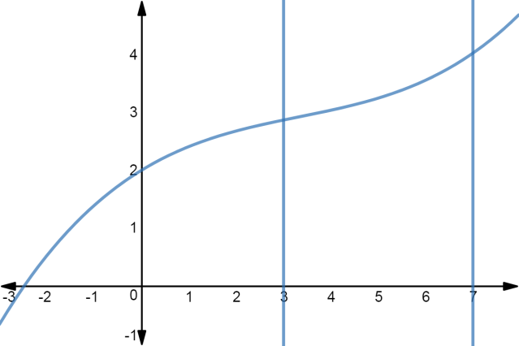

x

The accompanying table shows the value of the function $f(x)$ for

various values of $x, 3≤x≤7.$

The value of the area of this region is $\int_{3}^{7}{f\left(x\right)dx}$ which may be approximated

using the Trapezoidal rule:

$\int_{a}^{b}{f\left(x\right)dx≈\frac{1}{2}}h(y_{0}+2y_{1}+2y_{2}+…+2y_{n-1}+y_{n})$

or using Simpson’s rule:

$\int_{a}^{b}{f\left(x\right)dx≈\frac{1}{3}}h(y_{0}+4y_{1}+2y_{2}+4y_{3}+2y_{4}+…+2y_{n-2}+4y_{n-1}+y_{n})$

where, in each case, $y_{0}=f\left(x_{0}\right)=f\left(a\right), y_{n}=f\left(x_{n}\right)=f(b)$ and $h=$ $\frac{b-a}{n}$

1. Use Simpson’s rule over 4 intervals to approximate $\int_{3}^{7}{f\left(x\right)dx}$ (3 marks)

✓

✓

✓

1. Use the Trapezoidal rule over 5 intervals to approximate $\int_{3}^{7}{f\left(x\right)dx}$ (3 marks)

✓

✓

✓

1. For $y=f(x)$ the following sums were determined

$\sum_{i=1}^{9}{y_{2i}}$ $=29.73$ and $\sum_{i=1}^{10}{y_{2i-1}}$ $=33.16$

Use these sums and Simpson’s rule over 20 intervals to estimate the area of the region.

(4 marks)

✓

✓

✓

✓

**End of Section Two**